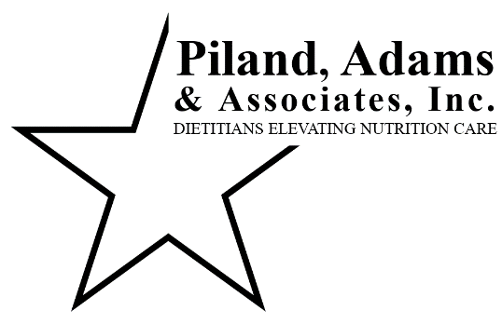**Consultant Dietitian FAQs**

**What is an RD, LD?**

All of our Consultant Dietitians are registered and licensed. A Registered Dietitian (RD), Licensed Dietitian (LD) requires a Bachelor’s Degree in a Nutrition related field, an internship approved by the Commission on Dietetic Registration and successful completion of the national credentialing exam. Most Dietitians also have a Master’s Degree.

RDs are registered with the Commission on Dietetic Registration, a national accreditation organization. LDs are licensed with the Texas Department of Licensing and Regulation, the state accrediting organization.

**What is the role of the Consultant Dietitian in a skilled nursing facility?**

Centers for Medicare and Medicaid Services (CMS) requires a qualified Dietitian for CMS funded facilities. Minimum hours are dictated per state requirements based on census. The dietitian should assess all new admissions, significant weight changes, wounds, residents of concern and everyone at minimum annually. Additionally, the dietitian will observe kitchen services – see below.

**How does the Consultant Dietitian spend their time?**

Monthly allotted hours are agreed upon by PAA and the facility administration based on census, acuity, admissions and readmissions and services requested. Majority of the Dietitian’s time is spent gathering patient information, visiting patients and documentation.

The dietitian will assess patients based on information gathered from nursing, therapy and dietary, patient and or family interviews, hospital records, laboratory results, observations and EMR documentation. Assessments will be completed in the EMR and with communication to the facility and physician of any nutrition recommendations. Patient assessments will comprise roughly 80% of the dietitian’s time.

The dietitian will also observe meal service and complete a kitchen audit at least monthly. At the end of each visit, the dietitian will exit (provide a report and review recommendations and concerns) with administration (based on facility preferences: Administrator, Director of Nursing, Dietary Manager, etc.).

Additional services are available upon request or RD recommendations such as mock survey, discharge education, additional staff education above monthly inservicing, menu revisions, budget review, tray card audit, care planning or MDS assistance, dietary manager course preceptor, etc.

**How does the Consultant Dietitian determine who they will assess?**

PAA dietitians assess patients on admissions (regulation requires within 30 days of admit), readmission, significant weight change (5% x 1 month, 7.5% x 3 months, 10% x 6 months), wounds, residents of concern per nursing, therapy or dietary, every patient quarterly to catch trending weights, labs, diet changes, etc.

**What does the Consultant Dietitian do in the kitchen?**

The dietitian observes, evaluates, audits and makes recommendations based on kitchen production at least monthly. This includes the following tasks or topics

* observing meal preparation and service; menus and recipes appropriate and followed
* quizzing staff on appropriate procedures, safe food handling and infection control practices
* approving menus and signing off on menu substitutions, auditing diet and supplement orders
* educating staff and checking credentials for the Dietary Manager and food service staff.

The dietitian will also make best practice recommendations based on federal and state regulations, current research, anecdotal experience and current survey interpretative guidelines.